1.Create a Calculated Column for 'Category Type': Add a calculated column in the
Order Details table that combines the 'Category' and 'Sub-Category' columns into a
single 'Category Type' column.

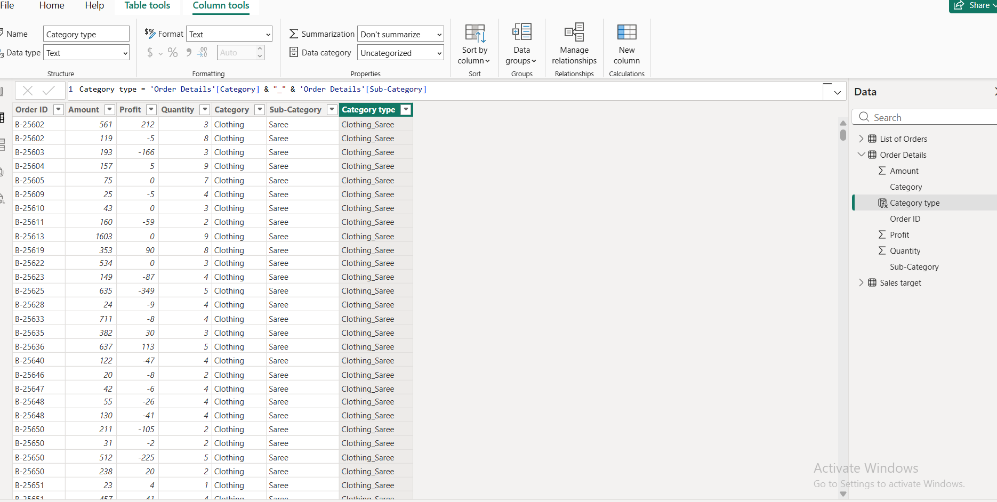

2.Calculate Revenue per Order in Order Details Table: Create a calculated column in
the Order Details table to compute the revenue (Amount * Quantity) per order.

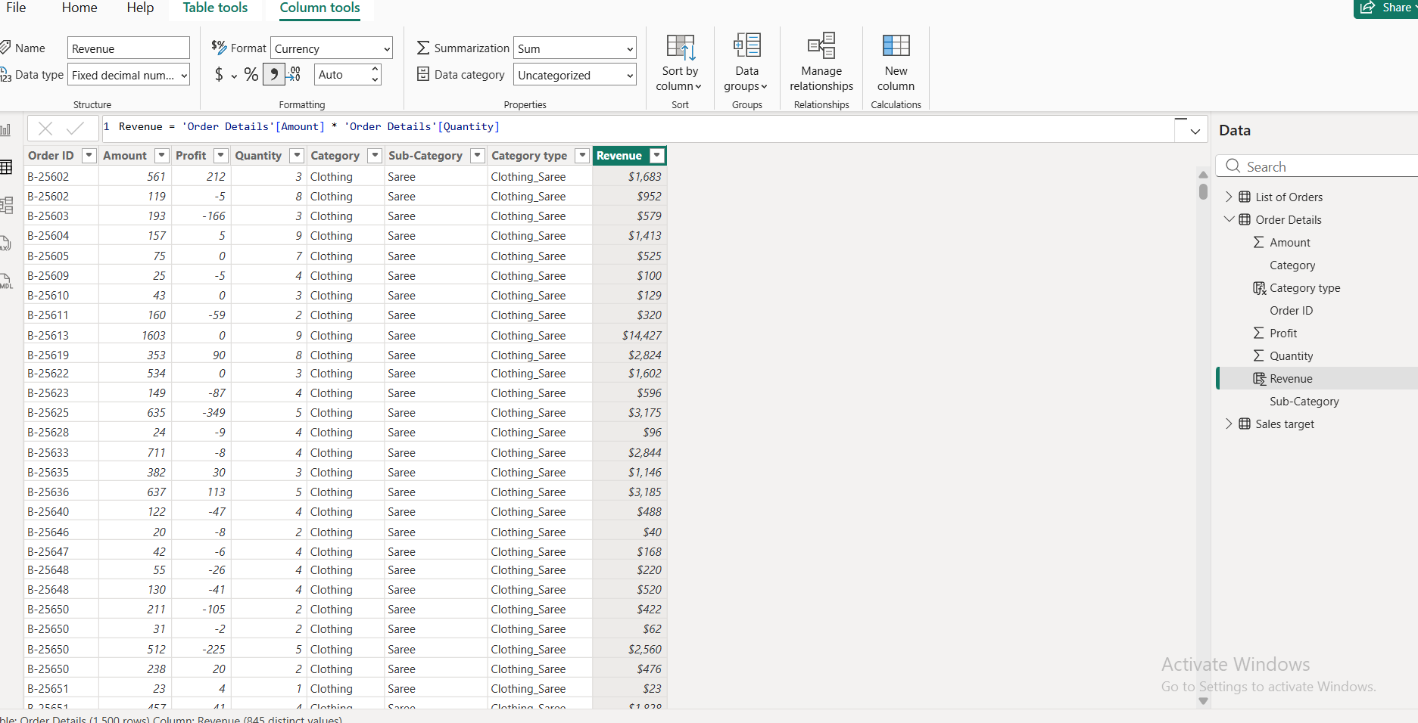

3.Create a Calculated Column to Categorize Sales: Add a calculated column named
‘Sales Category’ in the Order Details table that categorizes each order as 'Above
Average' or 'Below Average' based on the Amount value.

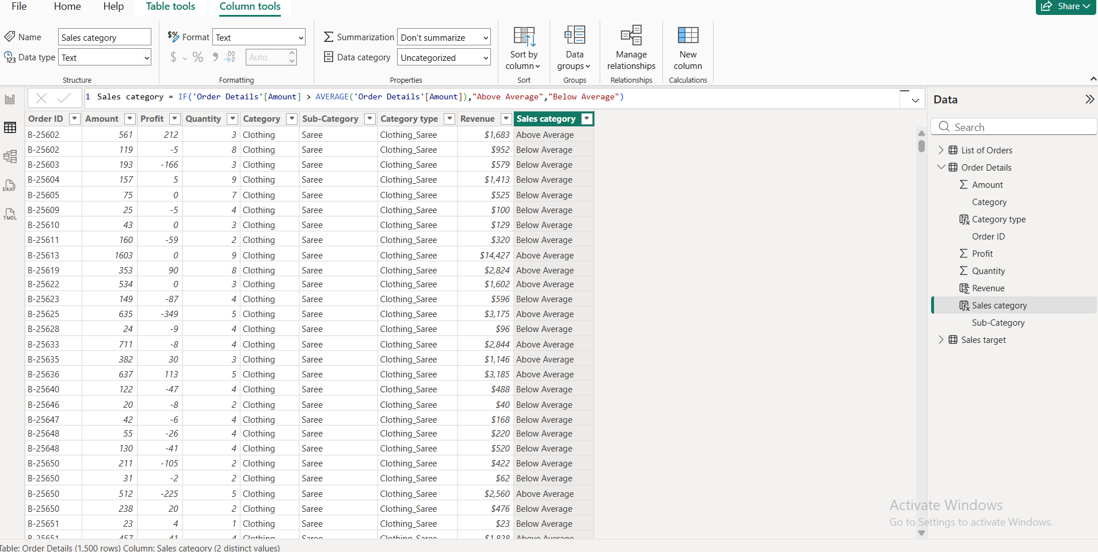

Calculated Measures:
● Calculate Order Count: Define a measure to count the total number of orders in the
Order Details table.

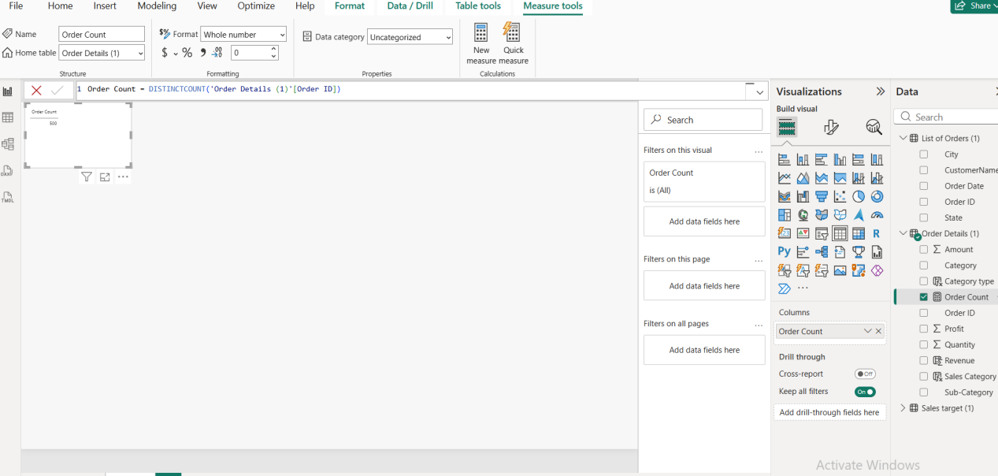

Calculate Average Profit in Delhi: Create a measure to calculate the average profit for orders placed in Delhi.

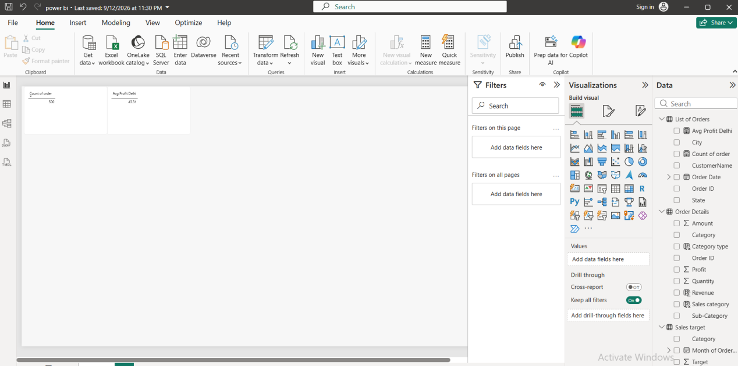

Calculate Year-to-Date (YTD) Sales: Define a measure to calculate the total sales amount accumulated from the earliest order date up to each order date.

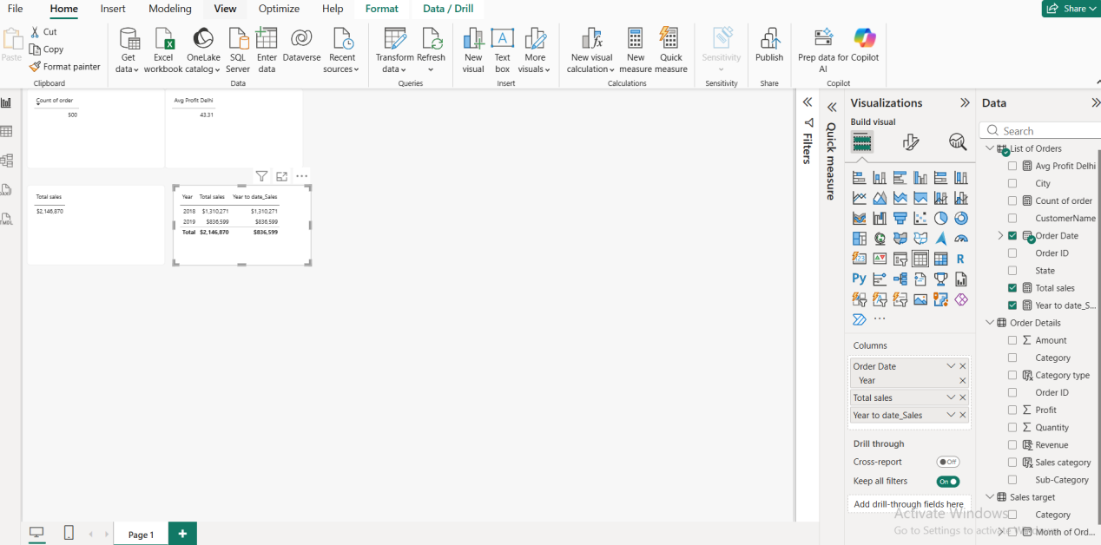

Data Visualization:

Sales Target Achievement by Category: Compare actual sales with sales targets by category using a clustered column chart.

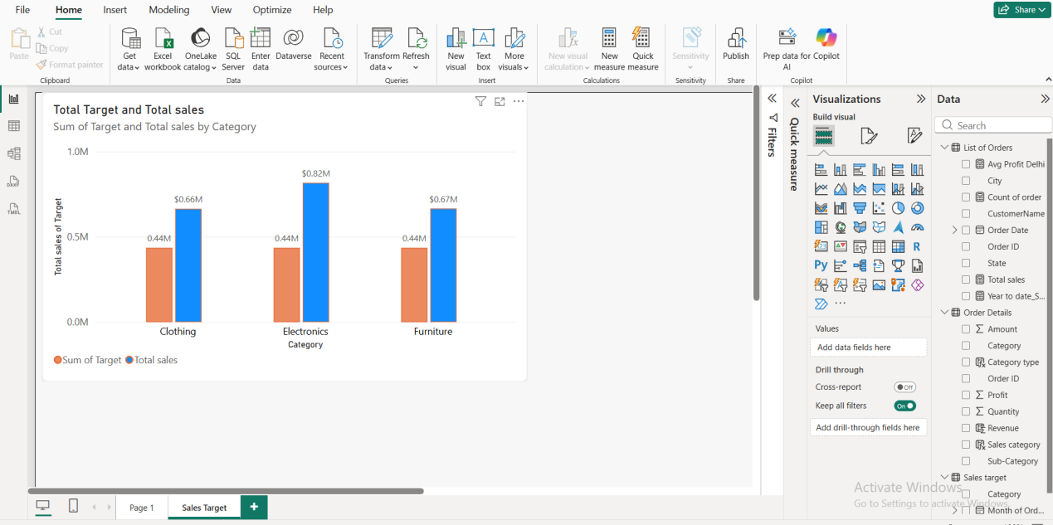

Max Profit Margin by Sub-Category: Analyze the maximum profit margin for each sub-category of products using a donut chart.

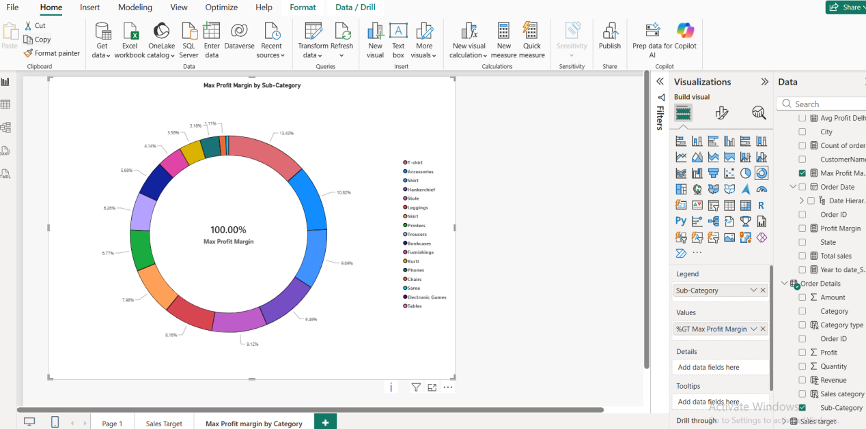

Monthly Sales Trend: Show the trend of monthly sales over time using a line
chart

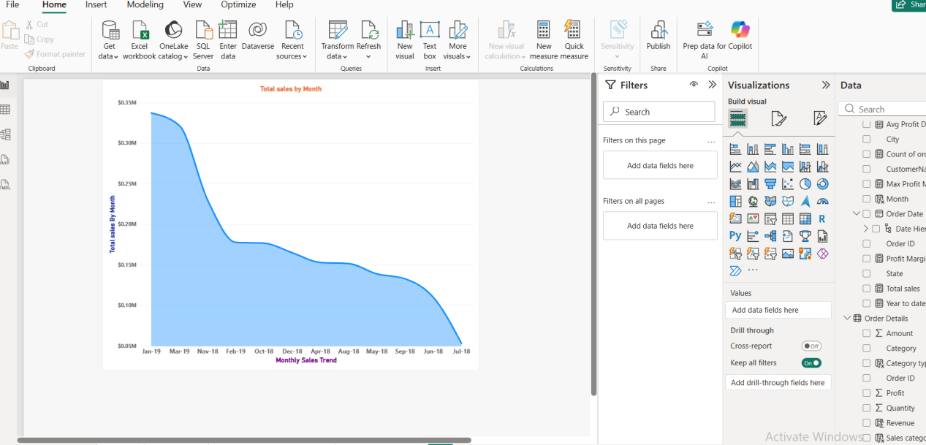

Comparison of Profit and Quantity by Sub-Category: Compare the relationship between profit and quantity sold for different sub-categories using a scatter chart.

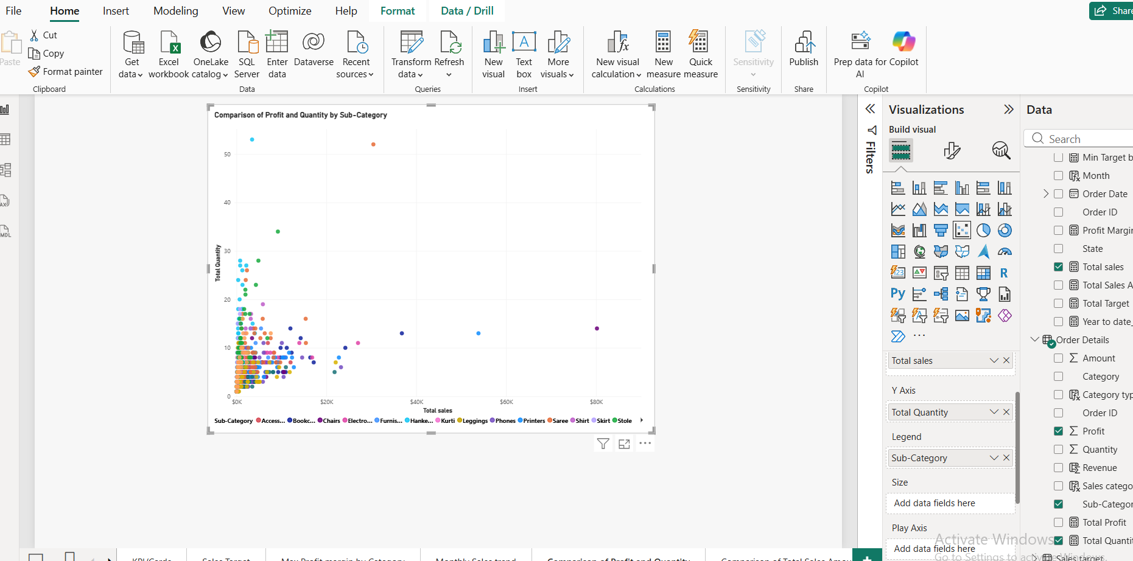

Comparison of Total Sales Amount and Target: Create cards to succinctly display the total sales amount alongside the sales target for quick comparison and analysis. Also, create a multi-row card to display the minimum target for each segment.

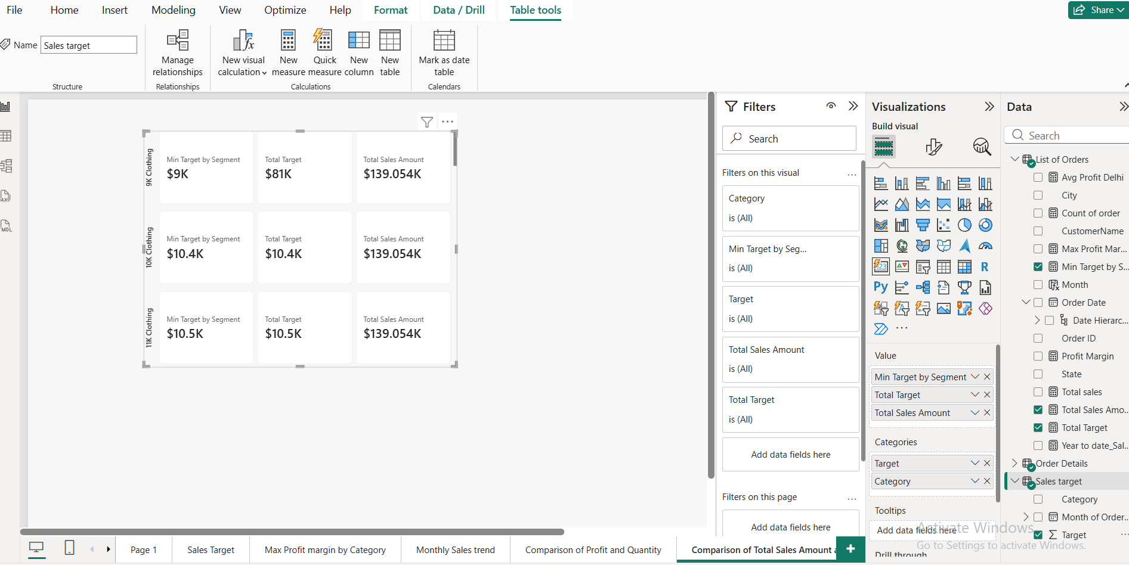

Sales Performance Matrix: Build a matrix view to analyze how actual sales compare to sales targets across different categories and months.

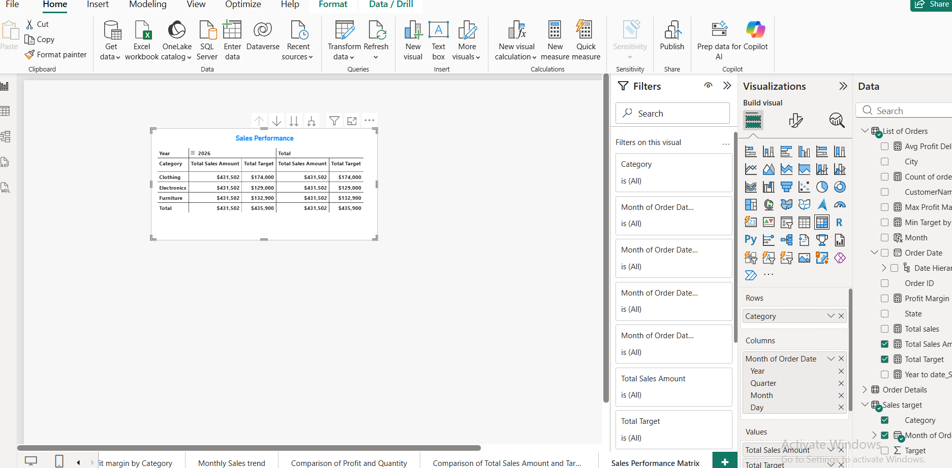

Geographic Sales Analysis: Visualize total sales on a map by city to identify regional sales patterns.

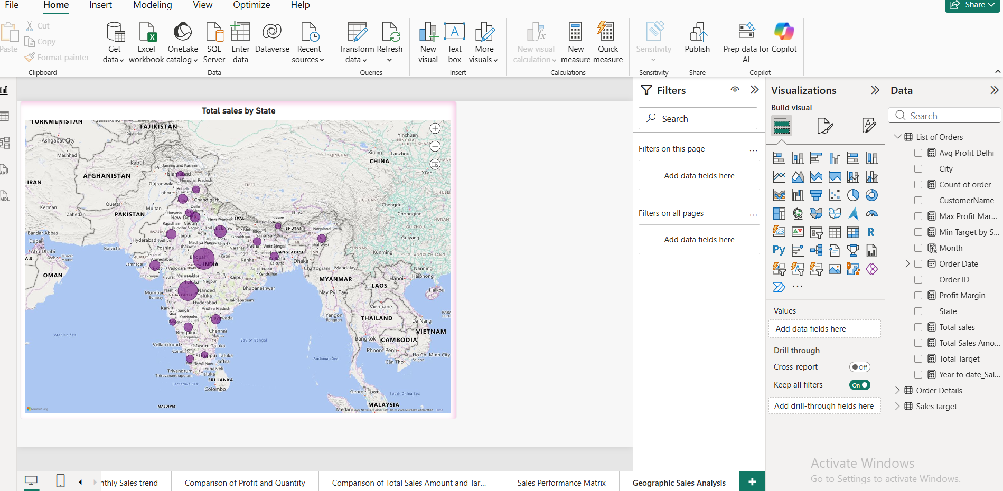

Sales Distribution by Sub-Category: Represent the sales distribution across different sub-categories using a treemap.

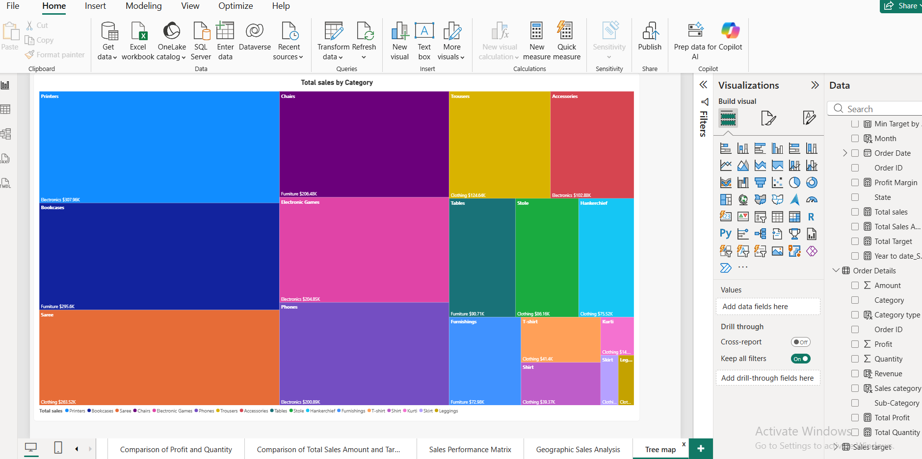

Order Count Analysis by State: Create a funnel chart to visualize the distribution of order counts across different states.

